The valve is a Humphreys 320 model 24 VDC 8 Watt direct solenoid valve:

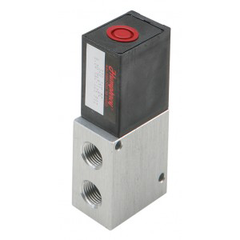

It has flying leads about 300 mm long. 18 AWG polarity doesn’t matter.

<https://www.pneumation.ca/wp-content/uploads/2014/03/9-320-420-TECHNICAL-SECTION.pdf>

<https://airinc.net/wp-content/uploads/2014/09/Humphrey_320-420.pdf>

flow sensors:

|  |
| --- |
| FS6122-100F100-100P100-TH1 |

Qty 4 will arrive May 13

<https://www.servoflo.com/download-archive/data-sheets/254-mass-flow-vacuum-sensors/1220-fs6122-datasheet>

100 LPM forward

100 LPM reverse

100 cm forward pressure

100 cm reverse pressure

Temp and humidity

|  |
| --- |
| **FS1015CL-100-ISO-A** |

Qty 2 will arrive May 2

<https://www.servoflo.com/mass-flow-sensors/siargo-mass-flow-sensors/1223-fs1015cl>

100 SLP forward flow

ISO connection

Calibrated for air